|  |  |  |  |  |  |  |
| --- | --- | --- | --- | --- | --- | --- |
| **Affiliation:**  FAST-NUCES KARACHI Pakistan | | | | | | |
| **Specialization:**  Information Technology Artificial Intelligence  Computer Vision | | | **Department:**  Computer Science and Computer Information Systems Department, Faculty of Computing, and Information Technology | | | |
| **Domain** Applied Research | | |
| **Proposal Title:** Aabi.Zaraat.ai | | | | | | |
| **Desired Starting Date**  1st October 2023 | | **Proposed Duration**  **(Max months)**  12 Months | | | **Required Budget**  **US dollars** 18160 | |
| **Nationality** | **Investigator’s Affiliation (Dept. / College)** | | | **Academic Title** | | **Name of the Investigator(s)**  **(Full Name)** |
| Pakistani | Computer Science Department FAST-NUCES Karachi Pakistan | | | Assistant Professor | | Principal Investigator  **Dr.Muhammad Farrukh Shahid** |
|  |  | | |  | | Team Members  **Aun Ali (20K-0286)**  **M. Mudabbir (20K-0273)**  **M. Fahad (20K-0441)** |
| **Signature of Principal Investigator** | | | | | | |

**Abstract**

In the domain of research and development, our FYP project introduces an innovative mobile application that is tailored for business-to-business (B2B) users. Via the use of smart phone, users can seamlessly employ their device cameras to identify and classify diverse soil types and fish species that is locally found across Pakistan.

In case of soil classification, our mobile app allows users with comprehensive insights into the identified soil's properties. It provides detailed information on the recommended fish species, accompanied by precise ingredient proportions details (fish hydrolysate). This amalgamation enhances protein levels within the specific soil, resulting in an optimal soil health.

In the context of fish classification, our app will offer all the relevant details of the fish that includes fish health, freshness, and the presence of any potential diseases. Moreover, the app also instructs user with precise blending instructions, specifying the optimal combination of fish species, other ingredients, and suitable soil types for achieving the best outcomes. With modern technologies and intelligent techniques, our project achieves great success in the domain of both agriculture and aquaculture.

**Keywords:** Artificial Intelligence, Deep Learning, Computer Vision, Agriculture, Aquaculture, Economical.

1. **Introduction**

In recent years, Artificial Intelligence (AI) has improved significantly due to many developments and advancements in the field. Many mobile applications are being built in the domain of AI that are accessible through our trusty smart phones.

The usability of AI is further extended by techniques such as Deep learning (DL) and Computer Vision (CV), which happens to be our domain of research and development. Deep learning and computer vision are two cutting-edge fields of artificial intelligence that have found extensive applications in various real-life scenarios, transforming industries and enhancing our everyday experiences. These technologies have demonstrated remarkable capabilities in recognizing patterns, extracting meaningful information from visual data, and making intelligent decisions based on visual inputs.

In our project, we will be focusing on the intersection of modern available technological prowess and the vital sectors of agriculture and aquaculture in Pakistan by harnessing the extended techniques AI has to offer. The backbone of Pakistan's economy is agriculture, and as time progresses, the agricultural system of Pakistan calls for an innovative solution that can bridge the gap between technology and farming. This need forms the backdrop for our project.

Picture a mobile application that uses the power of smart phone's camera to revolutionize two critical aspects of Fish Hydrolysate [1]: soil classification and fish assessment. Fish hydrolysate, a nutrient-rich liquid or powder produced from fish waste and byproducts, serves as a valuable organic fertilizer and soil conditioner, enhancing plant growth and soil health. We aim to leverage its potential to improve agricultural activities on poor soil. This application is specifically designed for business-to-business (B2B) users, opening up a plethora of possibilities in the agricultural landscape of Pakistan.

When the app is being used for soil classification, it becomes a knowledgeable ally for farmers and soil inspectors. Along with identification of soil, the app offers great insight into each soil type's unique properties. Moreover, the app also offers recommendation of the most compatible fish species for a given soil. The application also provides the user with precise instructions on the incorporation of fish hydrolysate, a strategic move to boost soil protein levels and enhance overall soil health.

Moving on to the next use case of our project, which is fish classification [2][3]. The dataset that will be used to train the model for fish classification will be collected locally (commonly found in the fish markets of Karachi), just like the soil dataset. The application will provide extensive information about the fish under scrutiny, including detailed health assessments [4][5], freshness checks, and disease detection [6][7]. The application will also guide the user on the ideal combination of fish species, additional ingredients, and compatible soil types to achieve optimal results.

With this technologically innovative project, we aim to practically create a farming companion. The application will simplify the complexities of agriculture while automating the Fish Hydrolysate procedure. With just a single tap on the screen, users can access a realm of agricultural insights, making their farming endeavors smarter, more efficient, and undoubtedly more accessible. The core of our project is to promote intelligent and sustainable agricultural practices. With our project, this goal is well within reach. In the following Fig 01, we can observe how agriculture and aquaculture are interlinked with each other.

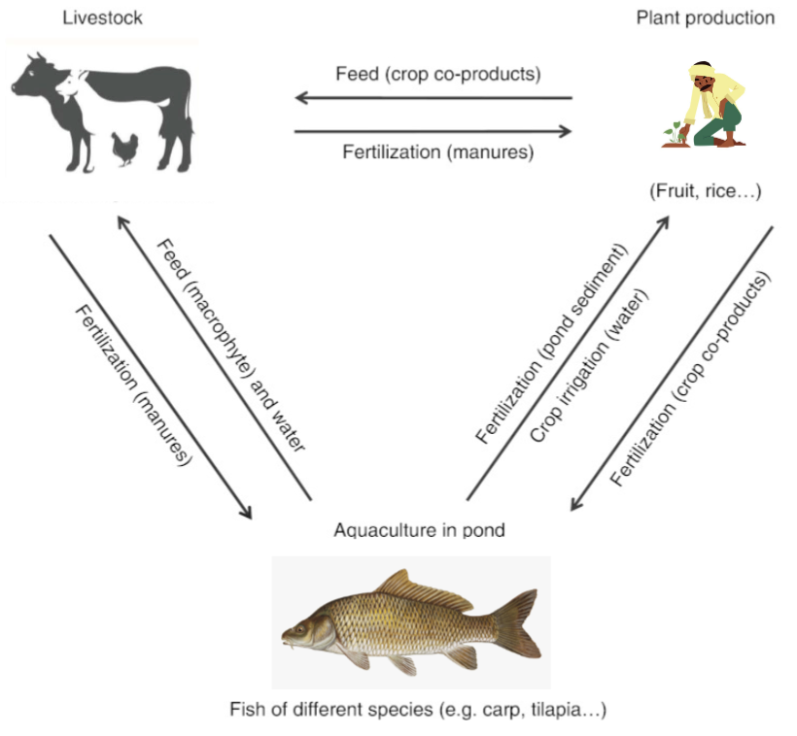

Fig 01: Integrated agriculture–aquaculture systems flow diagram

1. **Literature Review**

In recent years, the fusion of artificial intelligence (AI) with agriculture, often referred to as "AgriTech," has gained significant attention in research and practical applications. This is further enhanced when such techniques are met with traditional practices of aquaculture. Via the use of such AI techniques, many aspects of agriculture (e.g., aquaculture and agricultural soil management) are revolutionized. DL has been very important in enhancing agriculture process via image recognition and speech recognition (LeCun et al., 2015; Schmidhuber, 2015). DL's has the ability to find complex patterns in data through neural networks with multiple layers has opened new avenues for agricultural innovation (Goodfellow et al., 2016).

In the context of aquaculture, DL models have been used to classify fish species based on images (Deng et al., 2013). Via the use of Convolutional Neural Networks (CNNs), which has emerged as a potent tool for this purpose, accurate species identification is provided (Krizhevsky et al., 2012). Additionally, DL assists in monitoring fish health, assessing freshness, and detecting diseases, ensuring the well-being of aquatic populations (Esteva et al., 2017). Machines are enabled to interpret visual information via the use of computer vision (Szeliski, 2010). As of late, both DL and CV are converging in order to extract more benefits the AI technology has to offer in the fields of agriculture and aquaculture. Combining these technologies will empower the development of comprehensive aquaculture management systems, optimizing fish farming practices and enhancing soil health (Redmon et al., 2018).

Motivated by the various work presented above by the researchers, we propose to develop an application that uses the above-mentioned AI techniques to simplify the process of Fish Hydrolysate. The proposed method is novel because it seamlessly integrates modern available technology with traditional practices of agriculture and aquaculture in order to achieve an economical and feasible goal.

|  |  |
| --- | --- |
| **Team**  Aun Ali, M. Mudabir & M. Fahad  *Each will be contributing an equal amount in the overall work | **Novelty**  1) Self collected local dataset  2) Automated fish hydrolysate system  3) Efficient use of available resources  4) Mobile App that is intended for B2B users |

1. **Description (Rationale) Of the Proposed Work**

In this work, we consider the problem of classifying different kinds of fishes and soil that are best compatible with each other. Creating a fish fertilizer for a soil is a practice that is commonly found in the agriculture sector of Pakistan. However, as of yet, poor procedure is followed that is inefficient with currently available resources. With our mobile application, we can make better use of available resources that will in result yield significantly better result. The heart of our project lies in the utilization of locally sourced datasets, that is collected from the city of Karachi. These datasets form the backbone of our classification system, ensuring that the app is finely tuned to the specific soil and fish varieties found in our region.

In this project work, we consider a soil or fish that needs to be classified in order for the process of fish hydrolysate to proceed, and propose a novel method to automate such procedure via the use of AI present within our mobile application. Figure.02 shows a considered scenario for this work that contains a visualized workflow of our automated system. The user provides the system the image of fish or soil which is then processed by our application and finally the processed file is provided back 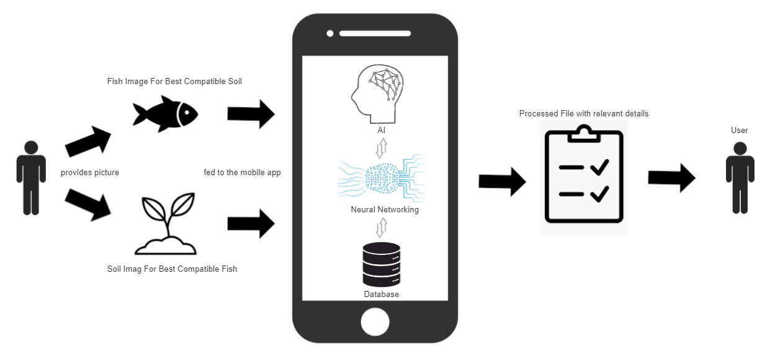to the user with all the relevant details.

Fig.02 Considered scenario for the proposed work

We transfer learned with ResNet V0 model on our dataset after dividing it in 70%-30% training and testing sub dataset. Along with this, we will also be doing fine tuning of the last 5 layers (may change during experimentation) in order to further increase the accuracy of feature extraction of our image dataset. This methodology can potentially result in accuracy that is greater than 94%. Once the specified image is classified, user is provided with all the relevant information of the object present in the image via fetching information from database. Fig.02 briefly visualizes the basic workflow and how different components of the system work with each other.

1. **Research Objectives**

The main objective of this research project is to build, automate and ease the procedure of Fish hydrolysate (creation of fish fertilizer for enhancing the nutrient level of soil). The main objectives are as follows.

1. **Soil Classification:** Developed a robust soil classification system that utilizes the mobile app's camera to accurately identify and classify various soil types commonly found in Pakistan. The system will provide detailed information about each soil type, including its properties, composition, and suitability for specific agricultural purposes. It will also tell the user the most compatible fish (required for protein enrichment) for that particular soil.
2. **Fish Classification:** Implemented a comprehensive fish classification module within the mobile app. Users will be able to capture images of locally found fish species, and the app will classify them with high accuracy. The classification will include details about the fish's name, health, freshness, and the presence of any diseases. The app will also tell the most compatible soil (for creation of fish fertilizer) for that particular fish.
3. **Data Collection:** Gathered extensive datasets of soil samples and fish species from the local Karachi market. These datasets served as the foundation for training and testing the deep learning algorithms used in the classification processes.
4. **Algorithm Development:** Deep learning algorithms, such as ResNet V0 (may change), were used for both soil and fish classification. This will be further fine-tuned in order to achieve a classification accuracy of nearly 95%.
5. **User Interface:** Design an intuitive and user-friendly interface for the mobile app to ensure ease of use for B2B users. The app will provide a friendly experience for capturing images and receiving classification results.
6. **Database Integration:** Create a centralized database that stores information about various soil types, fish species, and their compatibility. When soil or fish is classified, the app will retrieve relevant data from the database and display it to the user.
7. **Recommendation System:** Implemented a recommendation system that suggests the most compatible fish species for a given soil type and vice versa.

The tables 4.1 and 4.2 maps the objectives, approaches, phases, and the tasks carried out to implement the objectives.

**Table 4.1 OBJECTIVES AND THEIR APPROACH MAPPING**

|  |  |
| --- | --- |
| **Objective** | **Approach for achieving the objective** |
| 1 | Use Fine-Tuned Transfer Learning on locally collected soil image dataset |
| 2 | Using Fine-Tuned Transfer Learning on locally collected fish image dataset |
| 3 | Gather local soil and fish datasets from Karachi, preprocess and augment the data for training deep learning models |
| 4 | Implement ResNet V0 (may change) with transfer learning and fine-tuning for both soil and fish classification, achieving an accuracy of nearly 95%. |
| 5 | Develop an intuitive interface (via mobile development platforms) for easy image, resulting in a seamless user experience. |
| 6 | Create a centralized database (e.g., SupaBase or MongoDB) to store soil and fish information. Then integrating it with the mobile app in order to get real-time data retrieval |
| 7 | Implement a recommendation system based on soil-fish compatibility, resulting in an enhanced user decision-making. |
| 8 | Develop a fish health assessment system for disease detection and health evaluation via training on available dataset. |

**Table 4.2 OBJECTIVE PHASES AND TASKS MAPPING**

|  |  |  |
| --- | --- | --- |
| **Objectives** | **Phases** | **Tasks** |
| 1 | Comprehensive literature survey | Perform a comprehensive literature survey to further develop strong intuition about the state-of-the-art research methods in automating the traditional Fish Hydrolysate procedure. |
| 2, 3 & 7 | Data Collection | 1. Visit local fish market for images. 2. Visiting different sites in order to get more insight on different kinds of soil. 3. Training and pre-processing those images for state-of-the-art deep learning algorithms to operate on. |
| 4, 5 & 7 | Feature extraction and Deep Learning Model | 1. Extract the features from the image dataset. We extract the patterns found in soil and fishes. 2. Train the deep learning model even more by providing extracted features from the dataset. |
| 4 | Model Tuning | Train the model by considering different hyper parameters. Avoid model overfitting and underfitting issues by doing training several times. |
| 5 & 6 | Evaluation | Validate and test the model and check the performance using confusion matrix along with other validation check e.g., F1 score. |
| 7 & 8 | Develop a Product and mobile application and write-up | 1. Transform the model into the product and developed mobile application.  2. Write project progress reports  3. Publish work in conferences and/or journals |

1. **Scope**

Our innovative mobile application, that is driven by AI and computer Vision, holds great potential in revolutionizing the aquaculture (a field that is usually overlooked comparatively to agriculture of Pakistan) and agriculture sectors within Pakistan. Challenges related to soil classification, fish identification and smart farming practices are addressed.

1. **Agriculture Transformation:** Our project brings forth a pioneering solution for businesses operating in the agricultural and aquacultural domains. By utilizing the resources provided by mobile technology and advanced AI algorithms, our aim is to empower users to make smart decisions about their soil and fish management practices.
2. **Increase Soil Proficiency and Decrease Import:** Pakistan's primary source of income is agriculture. With our project, soil inspectors will be able to make wise decisions regarding the use of fertilizers on Pakistan's agricultural soil. This will also significantly reduce the need to import American soil for agricultural purposes in Pakistan, thereby saving substantial sums of money in Pakistan's consistently challenged financial treasury.
3. **Boosting Agricultural Yield:** The ability to provide tailored recommendations for fish farming can enhance agricultural yields. This is especially important in a country like Pakistan where agriculture is a primary source of income and livelihood for a substantial portion of the population.
4. **Environmental Benefits:** As facilitated by our project, precision agriculture and aquaculture reduce the indiscriminate, unnecessary and avoidable use of fertilizers and other resources. This has positive environmental implications, such as minimizing soil degradation and water pollution.
5. **Improved Food Security:** Enhanced agricultural practices lead to increased food production, which will in turn contribute to improvement in food security. With a growing global population, ensuring a stable food supply is of utmost importance.
6. **Empowering Farmers:** By providing easy-to-use tools for automation of Fish Hydrolysate, our mobile app empowers local soil inspectors. It creates easy access to critical agricultural knowledge, allowing individuals to make wise and informed decisions for improved crop and fish farming.

**6. Research Design**

Our research design comprises of several distinct phases, each contributing to the development of our AI driven mobile application that will leverage the cutting-edge technologies including advanced AI algorithms, machine learning and computer vision. The system will utilize real-time data acquisitions from smartphone’s hardware and use its computing capabilities to facilitate storage, analysis and more.

**The project will consist of the following phases:**

**6.1.1 Phase 1: Comprehensive Literature Review**

We conducted a comprehensive literature survey from multiple resources to determine the state-of-the-art techniques in the field. We will study various deep learning techniques within the domain of artificial intelligence. Additionally, we will explore research materials that cover the amalgamation of practices in both agriculture and aquaculture.

**6.1.2 Phase 2: Data Collection**

We visited local fish market in Karachi in order to collect a dataset by taking pictures. The same procedure will also extend to the collection of datasets for soil locally found in Pakistan. We aim to collect local dataset, which will be a significant challenge in our work.

**6.1.3 Phase 3: Data-pre-processing (Feature Extraction)**

After dataset collection, we extracted features (patterns) from the images (of fish and soil). This involves cleaning, organizing, and preparing the data for analysis. For soil data, we will extract relevant features related to soil composition and texture. For fish data, we will focus on fish attributes such as size, color, and shape like mentioned before.

**6.1.4 Phase 4: Deep learning model**

This is a crucial phase in our FYP life cycle. This is where we will be leveraging deep learning techniques along with transfer learning and fine-tuning strategies. We trained our model using the prepared datasets to achieve high accuracy in classifying soil types and fish species. Our aim is to surpass a 90% accuracy threshold.

**6.1.5 Phase 5: Mobile Application Development**

After training our model, we will be moving onto app development. Our app will be user-friendly and will be compatible with business-to-business (B2B) use. The deep learning model will work at the backend, taking care of classification procedure.

**6.1.6 Phase 6: Integration and Testing**

In order to ensure the application’s functionality, it will be rigorously tested on real-time local data (Karachi). This will provide valuable feedback for refinement.

**6.1.7 Phase 7: Evaluation**

We will evaluate the model by using confusion matrices and other validation techniques. We will plot some abnormal curves to analyze the performance of a model. Any shortcomings will be addressed, and optimization strategies will be implemented.

**6.1.8 Phase 8: Writing-up and documentation**

Throughout the project, we plan to maintain comprehensive documentation of our methodologies, data, code, and results. This documentation will further server as the basis for journal articles, conference papers, and project reports, sharing our findings and contributions with the scientific community.

1. **Research Methodology**

**7.1 Methodology**

As discussed in the preceding section, we will use deep learning for classification. We have described the previous section’s approach, task, and phases. Here, we aim to discuss experimental setup (on-site testing), deep learning model (training and testing phases), and evaluation criteria for the performance of our system.

**7.1.1 Data Collection**

As mentioned earlier in the document, we visited various sites in Karachi in order to collect an image dataset for classification of fish and soil. The data collection process will adhere to standardized methods and protocols to ensure accuracy and consistency.

**7.1.2 Feature Extraction**

After data collection, our focus shifted on feature extraction to allow effective classification. Features related to soil composition, texture, and nutrient content will be extracted for soil classification and in the case of fish classification, features such as fish morphology, coloration, and scale patterns will be extracted. The collected data will be preprocessed in order to enhance its suitability for deep learning algorithms. Figure 3 provides a visual representation of the backend for fish and soil classification.

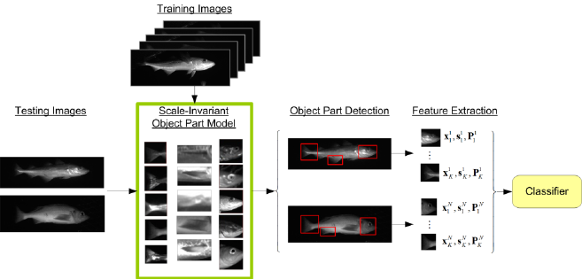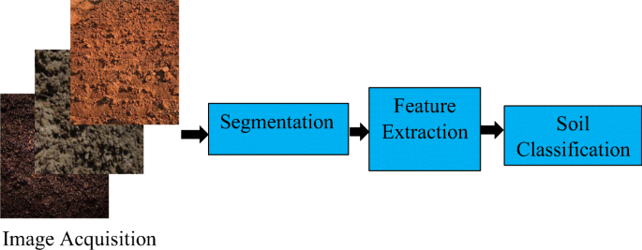

Figure.03 Fish and Soil Classification (respectively) Visualized

**7.1.3 Deep learning model**

Through our current research we aim to integrate different models for each respective stage and determining which model works best for each phase. Although the current shortlisted algorithms we have considered include ResNet V0, GoogleNet and EfficientNet, we aim to configure models based on how accurate they tend to perform on respective stage of the process rather than determining immediately before testing.

**7.1.4 Evaluation**

We will apply test data containing abnormalities to the trained model and assess the performance by plotting confusion matrices among other forms of accuracy detection. Moreover, we aim to plot several abnormality graphs which will show anomalies in the Classification.

**8. Project Outcomes and deliverables**

In conclusion, we want to use cutting-edge technology that follow industry-leading norms and legal criteria. The AI-driven fish fertilizers and which fish is best for that soil gadget will be able to stand as a solution in agriculture with favorable end-user feedback, user-friendly exterior packaging, and thorough documentation. The expected outcomes are as follows:

1. AI-Based model for Fish Classification
2. Give advice on the best fish fertilizer for that soil.
3. Compatibility with fish
4. by the help of computer vision this able detect any disease in the fish

**Table 8.1 maps the project outcomes with the strategic technology goals**

|  |  |  |  |  |
| --- | --- | --- | --- | --- |
| **PROJECT**  **EXPECTED**  **OUTCOMES** | **STRATEGIC TECHNOLOGY PROGRAM GOALS** | | | **PROJECT**  **OBJECTIVE**  **ACHIEVED** |
| **GOAL 1**  Advances in AI/Deep learning research | **GOAL 2**  Dataset Analysis | **GOAL3**  Developing Fish Hydrolysate System |
| (Original research) | √ |  |  | 7 & 8 |
| (AI-driven Fish Hydrolysate System) |  | √ | √ | 1, 3, 5 & 6 |
| (Accurate Classification) |  | √ | √ | 2 & 4 |

9) Future Work For FYP II (Deliverables)

- **Backend Development:**

- Completion of the backend infrastructure for the application.

- Implementation of the fish-to-soil and soil-to-fish mapper with advanced techniques.

- **Guidance on Nutrient Retrieval:**

- Inclusion of step-by-step guidance on nutrient retrieval from fishes for agricultural purposes.

- Providing users with a comprehensive understanding of the nutrient content for optimal farming.

- **Expanded Databases:**

- Enhancement of databases for both fish and soil.

- Inclusion of relevant details for accurate classification and mapping.

**9. RESULTS**

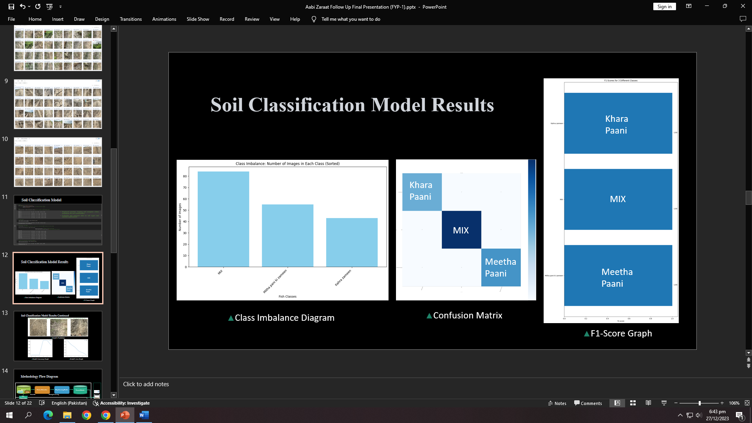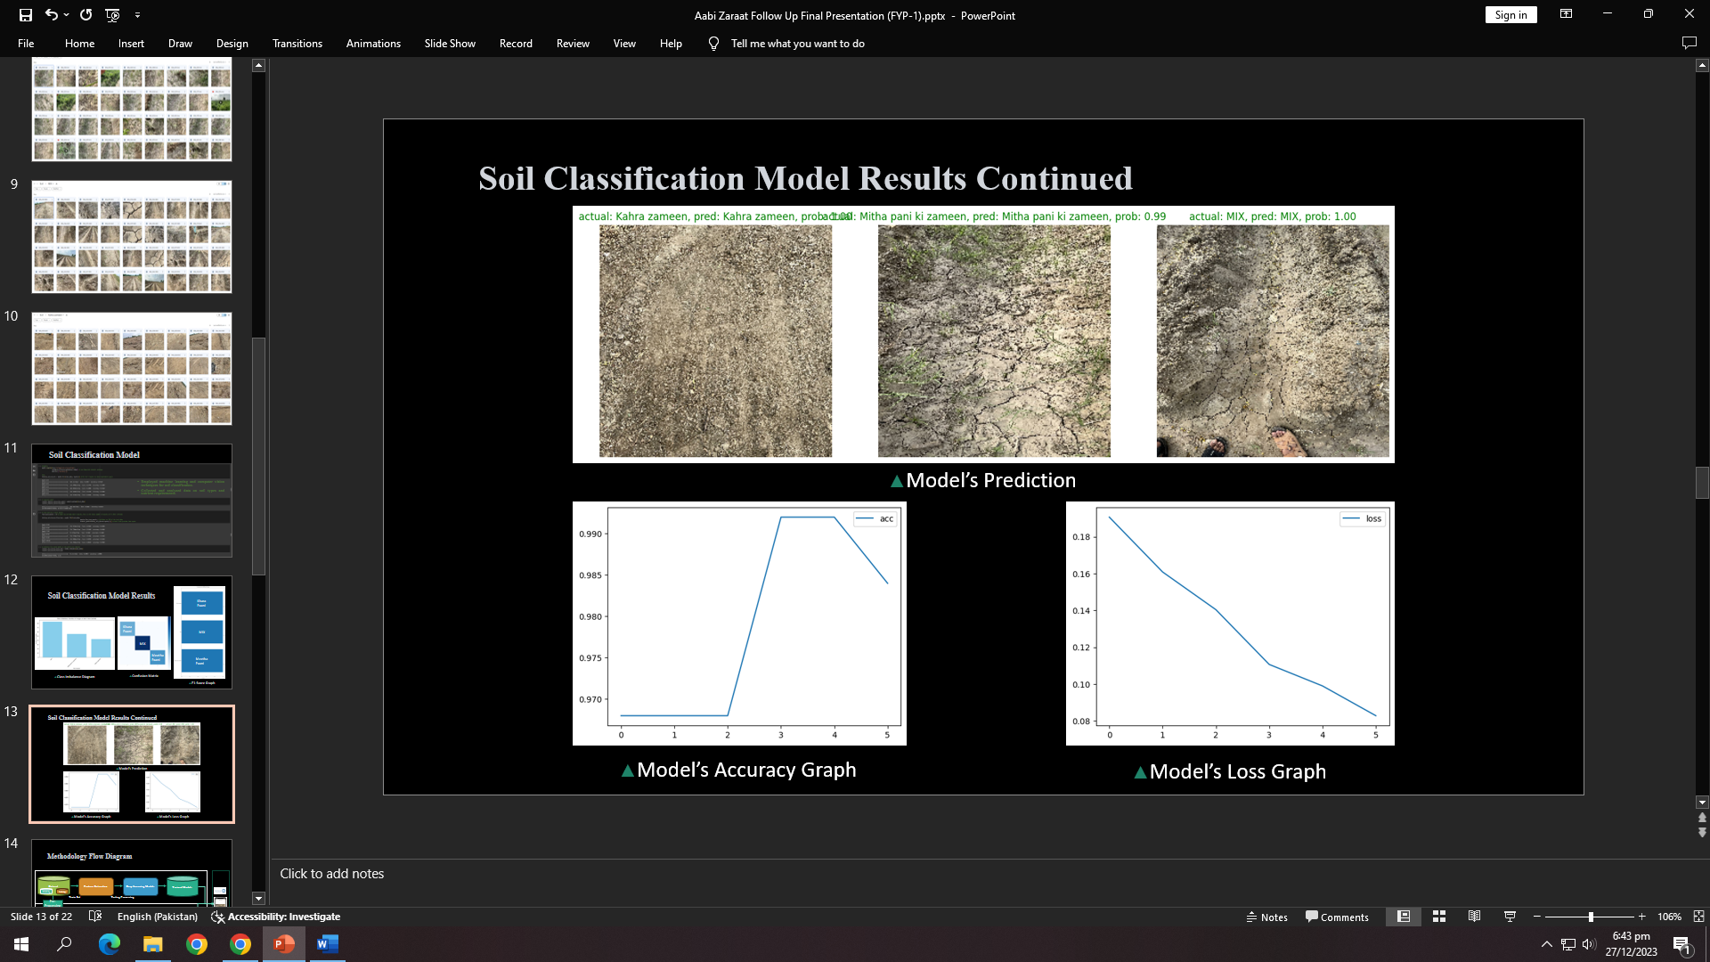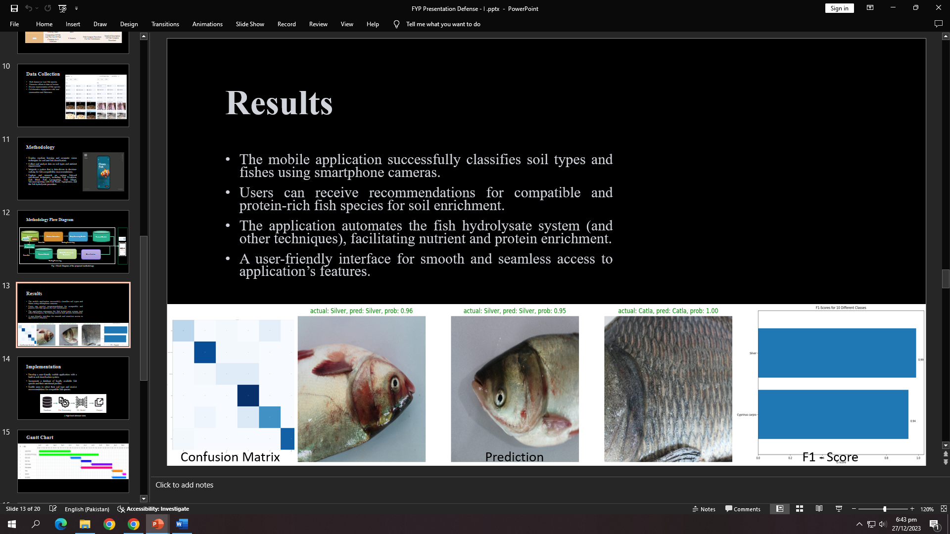

Fish Classification Model Results

**10. REFERENCES**

1. Deng, J., Dong, W., Socher, R., Li, L.-J., Li, K., & Fei-Fei, L. (2013). ImageNet Large Scale Visual Recognition Challenge. International Journal of Computer Vision, 115(3), 211-252.Esteva, A., Kuprel, B., Novoa, R. A., Ko, J., Swetter, S. M., Blau, H. M., & Thrun, S.
2. (2017). Dermatologist-level classification of skin cancer with deep neural networks. Nature, 542(7639), 115-118.Forsyth, D. A., & Ponce, J. (2011).
3. Computer Vision: A Modern Approach. Prentice Hall.Goodfellow, I., Bengio, Y., Courville, A., &Bengio, Y. (2016). Deep Learning. MIT press Cambridge, 1(4), 2.Krizhevsky, A., Sutskever, I., & Hinton, G. E. (2012). ImageNet Classification with Deep Convolutional Neural Networks.
4. Advances in neural information processing systems, 25.LeCun, Y., Bengio, Y., & Hinton, G. (2015).
5. Deep learning. Nature, 521(7553), 436-444.Mehrjou, A., Mahdavinejad, M. S., Mirtaheri, S. L., &Yaghmaie, K. (2020).
6. Applications of Computer Vision in Agriculture—A Review.
7. Biosystems Engineering, 191, 1-25.Redmon, J., Divvala, S., Girshick, R., & Farhadi, A. (2018).
8. You Only Look Once: Unified, Real-Time Object Detection. Proceedings of the IEEE conference on computer vision and pattern recognition, 779-788.Schmidhuber, J. (2015).
9. Deep learning in neural networks: An overview. Neural networks, 61, 85-117.Szeliski, R. (2010).
10. Computer Vision: Algorithms and Applications. Springer.